Vidya Sagar Reddy Dhoolla
vijay.nits0456@gmail.com
Executive Academic Capstone Report: Pneumonia Detection from Chest X-Ray Images
Capstone Project Report

Executive Academic Capstone Report: Pneumonia Detection from Chest X-Ray Images

Capstone Project: RSNA Pneumonia Detection Challenge
Deep Learning – Convolution Neural Networks – TensorFlow / Keras
Apple M1 GPU (TensorFlow Metal) – Python 3.12
Dataset | RSNA Pneumonia Detection Challenge (Kaggle)
Total Patient Samples | 26,684 unique chest X-rays (DICOM format)
Framework | TensorFlow 2.16 / Keras — Apple M1 GPU
Model Registry | https://huggingface.co/dvsreddy/pneumonia-detection-model
Best Model | ResNet50V2 fine-tuned —
Submission Type | Executive Academic Final Capstone Report
Date | July 2026

Abstract
This capstone project presents an interim deep learning pipeline for automated pneumonia detection from chest X-ray images using the RSNA Pneumonia Detection Challenge dataset. The work covers DICOM image ingestion, patient-level data preparation, exploratory analysis, preprocessing, baseline convolutional neural network development, and evaluation. The baseline CNN achieved a ROC-AUC of 0.8353, indicating meaningful discriminative capability, but pneumonia recall at the default 0.5 threshold remained critically low. The report therefore positions the current model as a reproducible academic baseline and identifies threshold calibration, transfer learning, higher-resolution inputs, and clinical decision-support framing as priorities for the final phase.
Keywords: pneumonia detection, chest X-ray, convolutional neural network, DICOM, RSNA, medical imaging, capstone project.

Executive Summary
The interim report covers the first phase of building an automated pneumonia detection system from chest X-rays: data understanding, exploratory analysis, preprocessing, and a Convolutional Neural Network (CNN) trained from scratch as a baseline.
Working from 26,684 DICOM Chest X-Rays (RSNA Pneumonia Detection Challenge), we established that true pneumonia prevalence is 22.5% - not the 31.6% the raw label file suggests – but leakage-safe stratified splits, and trained a 126,894-parameter CNN with class weighting. The baseline achieved Test ROC-AUC 0.8353 and importantly for a screening tool, 84% pneumonia recall all the default decision threshold – the class-weighted loss shifted the model toward the clinically safer operating point.
These results validate the full pipeline and set a strong baseline for the final phase, where transfer learning with pretrained backbones, threshold governance, and deployment as a web application will complete the system.

Business Context and Problem Statement
Pneumonia is a leading cause of death worldwide, disproportionately affecting children under five and the elderly. Diagnosis relies on chest X-Ray interpretation by radiologists – a scarce resource, particularly in rural and resource-constrained settings. Fatigue and high patient loads introduce diagnostic variability; delayed reads delay antibiotic treatment.
The business goal is a decision-support system that automatically flags likely pneumonia cases for priority radiologist review – increasing throughput and consistency without removing the clinician from the loop. For such a screening tool, missing a pneumonia case (false negative) is far costlier than a false alarm; this asymmetry drives every modelling decision in this report.

Objectives
The project aims to:
- Accurately classify chest X-ray images as pneumonia-positive or pneumonia-negative using deep learning.
- Assist healthcare professionals by providing a reliable, consistent second opinion to reduce diagnostic errors.
- Improve efficiency by enabling faster automated screening, reducing radiologist burden.
- Enhance accessibility by building a scalable solution deployable in hospitals, clinics, and rural health centers.
- Support global health by contributing to early detection, lowering pneumonia-related mortality, and reducing unnecessary antibiotic prescription.

Dataset Description
Source: RSNA Pneumonia Detection Challenge (Kaggle). The dataset consists of chest X-ray images stored in DICOM format (.dcm), the medical imaging standard embedding both patient metadata and raw pixel arrays in a single file.

Label Structure
File | Purpose
Stage_2_train_labels.csv | Binary label per bounding box row (Target: 0 or 1). A patient may appear on multiple rows if multiple opacity regions were annotated.
Stage_2_detailed_class_info.csv | Three-class label per patient (one row per patient).

Three-Class Taxonomy
Class | Binary Target | Meaning
Normal | 0 | Healthy lungs
No Lung Opacity / Not Normal | 0 | Chest abnormality present (e.g., cardiomegaly or pleural effusion) but not pneumonia
Lung Opacity | 1 | Pneumonia present — white/grey opacities visible in lung fields
Note: The ‘No Lung Opacity / Not Normal’ class is the most diagnostically challenging – these images show real pathology that can visually resemble pneumonia, making the negative class heterogeneous and the classification boundary harder to learn.

Data Overview

File Inventory
Asset | Details
data/stage_2_train_images.zip | 26,684 training DICOM files (~3.5 GB)
data/stage_2_test_images.zip | 3,000 test DICOM files (~380 MB)
stage_2_train_labels.csv | 30,227 rows x 4 columns
stage_2_detailed_class_info.csv | 30,227 rows x 2 columns

DICOM Image Properties
Inspecting file sample images directly from the zip archive:
File | Dtype | Shape | Pixel Min | Pixel Max
Sample 1 | uint8 | (1024, 1024) | 0 | 230
Sample 2 | uint8 | (1024, 1024) | 0 | 255
Sample 3 | uint8 | (1024, 1024) | 0 | 232
Sample 4 | uint8 | (1024, 1024) | 0 | 255
Sample 5 | uint8 | (1024, 1024) | 0 | 255
All images are 1024 × 1024 pixel, single-channel grayscale, uint8 arrays. The varying maximum pixel value (230 versus 255) confirms scanner-to-scanner intensity variation, making per-image normalization necessary.

Key Data Observations
Metric | Value
Training CSV rows | 30,227
Unique training patients | 26,684
Duplicate rows (Multi-box patients) | 3,543
Pneumonia patients after deduplication | 6,012 (22.5%)
Raw-CSV Pneumonia share (misleading) | 31.6%
Image properties | 1024x1024, uint8, single-channel grayscale
Pixel maxima across samples | 230-255 (scanner-dependent)
Important finding — raw CSV inflates pneumonia count. The CSV has 30,227 rows but only 26,684 unique patients. The extra 3,543 rows arise because pneumonia patients can have multiple bounding box annotations (one row per annotated opacity region). When deduplicated to patient level, the true pneumonia prevalence is 6,012 patients (22.5%), not 31.6% as the raw CSV implies. This makes the class imbalance more severe than initially apparent.
- All analysis must happen at patient level – labels deduplicated to one row per patient before any split or statistic.
- True class imbalance is 3.44 : 1, more severe than the raw file implies – accuracy alone cannot be the success metric.
- Scanner-dependent intensity ranges require per-image normalization rather than a single global scale.
- No RGB-to-grayscale conversion needed; a channel dimension is added programmatically for the CNN.

Exploratory Data Analysis

Patient-Level Class Distribution
After deduplication to one row per patient:
Class | Patient Count | % of Total
No Lung Opacity / Not Normal | 11,821 | 44.3%
Normal | 8,851 | 33.2%
Lung Opacity (Pneumonia) | 6,012 | 22.5%

Class Imbalance Analysis
Target | Patients | Percentage
No Pneumonia (0) | 20,672 | 77.5%
Pneumonia (1) | 6,012 | 22.5%
The dataset has a ~3.4:1 ratio of negative to positive patients. A naïve classifier that always predicts ‘no pneumonia’ would achieve 77.5% accuracy – highlighting why accuracy alone is a misleading metric for this task.
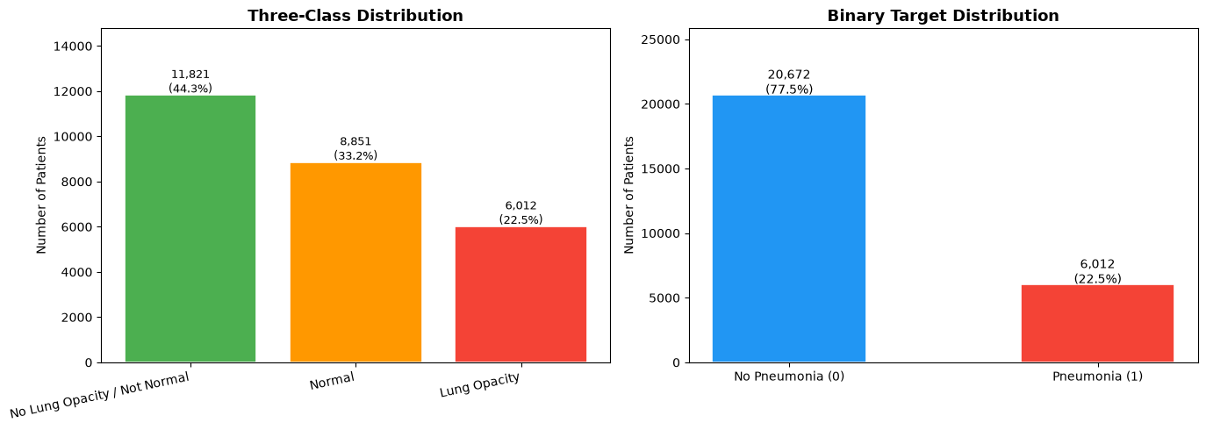
Figure 1. Patient-level class distribution after deduplication. The chart shows that pneumonia-positive cases represent 22.5% of the dataset, while the remaining 77.5% are non-pneumonia cases, confirming a clinically important class imbalance that must be considered during model training and evaluation.
Sample X-Ray Images per Class
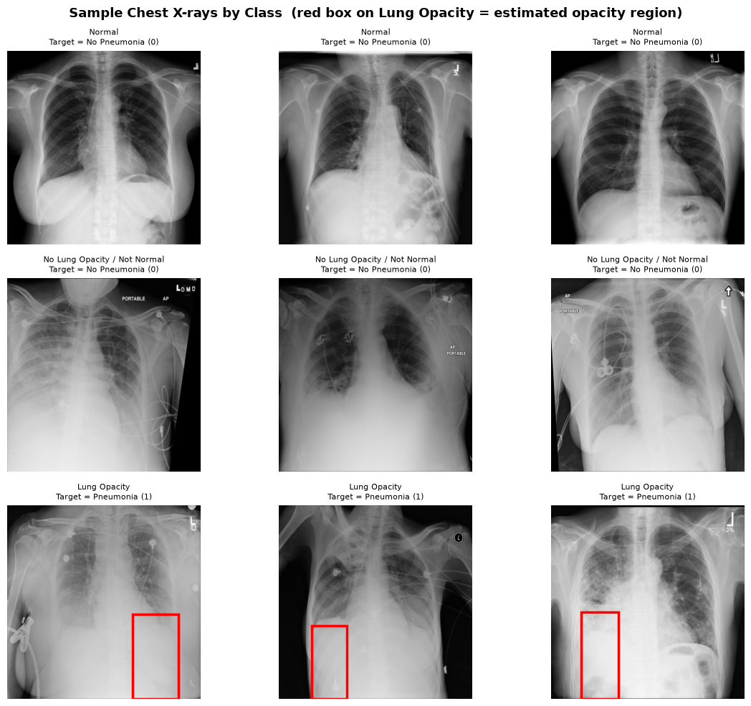
Figure 2. Representative chest X-ray examples from the three diagnostic categories: Normal, No Lung Opacity / Not Normal, and Lung Opacity / Pneumonia. The comparison highlights the visual distinction between clear lung fields, non-pneumonia abnormalities, and pneumonia-associated opacity patterns.

Visual Observations
Lung Opacity (Pneumonia — Target=1):
- Visible patchy white/grey opacities in one or both lung fields.
- Opacities appear as unilateral consolidations in early-stage pneumonia.
- The affected lung field loses its typical dark, air-filled appearance.
Normal (Target=0):
- Clear, uniformly dark lung fields on both sides.
- Sharp diaphragm outline and well-defined costophrenic angles.
No Lung Opacity / Not Normal (Target=0):
- Enlarged cardiac silhouettes, blunted costophrenic angles, or diffuse haziness.
- Real abnormalities but not pneumonia — the primary source of potential false positives.

Pixel Statistics per Class
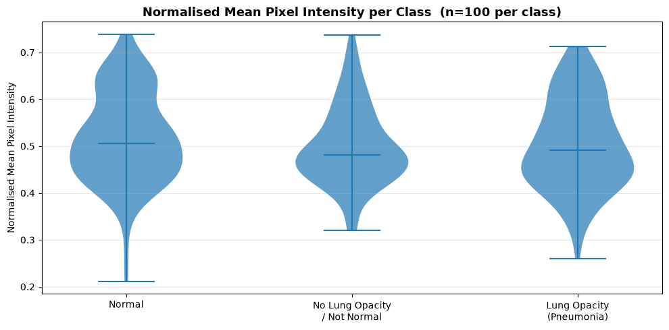
Figure 3. Pixel intensity statistics by class, showing mean intensity and standard deviation across sample images. Pneumonia images tend to demonstrate slightly higher intensity variation due to opacity regions, supporting the need for normalization and robust feature extraction.

Data Quality Notes
- Some DICOM files lack the standard DICM header — force=True is required.
- The training zip contains an extra 26,684 __MACOSX/ ghost entries (macOS artifact) that must be filtered.
- Files use a directory-prefixed path inside the zip, requiring a lookup dictionary rather than direct filename construction.
- Visual signatures exist and align with radiology: the task is learnable from pixels alone.
- The largest class (44.3%) is ‘Not Normal’ – pathology that mimics pneumonia – so false positives will concentrate there; the negative class is heterogeneous.
- Class weighting is required in the loss, and evaluation must lead with ROC-AUC and pneumonia recall, not accuracy.
- The intensity-separation finding motivates the CNN; if global brightness already separates classes weakly, learned spatial features should do far better.

Data Preprocessing

Image Extraction
Training DICOM files were extracted from the zip archive to data/train_images/ (one-time operation, ~3.5 GB on disk). A guard condition prevents re-extraction on subsequent runs.

Patient-Level Deduplication
stage_2_train_labels.csv was deduplicated by patientId (keeping one row per patient) and merged with stage_2_detailed_class_info.csv to yield a clean patient-level dataframe with binary target and three-class label.

Train / Validation / Test Split
Split strategy: stratified, patient-level, 70/15/15
Split | Patients | Pneumonia (Target=1) | % Pneumonia
Train | 18,677 (70% patients) | 4,208 | 22.5%
Validation | 4,004 (15% patients) | 902 | 22.5%
Test | 4,003 (15% patients) | 902 | 22.5%
The stratified split preserved the 22.5% pneumonia rate identically across all three splits, ensuring no class distribution drift between train, validation and test sets.

Preprocessing Pipeline
Each DICOM image was processed through the following steps:
- Read DICOM pixel arrays as grayscale images with shape H × W and uint8 data type.
- Cast to float32.
- Resize images from 1024 × 1024 to 128 × 128 using bilinear interpolation via OpenCV.
- Normalize pixel values by dividing each image by its maximum value, producing values in the range [0.0, 1.0].
- Add the channel dimension to convert each image from (128, 128) to (128, 128, 1).
Note on grayscale: DICOM chest X-rays are natively single-channel — no RGB-to-grayscale conversion is required. The channel dimension is added programmatically to satisfy the CNN's expected input shape.
Note on normalization: Per-image normalization (dividing by each image's own maximum) was chosen over global normalization because pixel intensity ranges vary across different X-ray scanners (maximum values observed between 230 and 255).
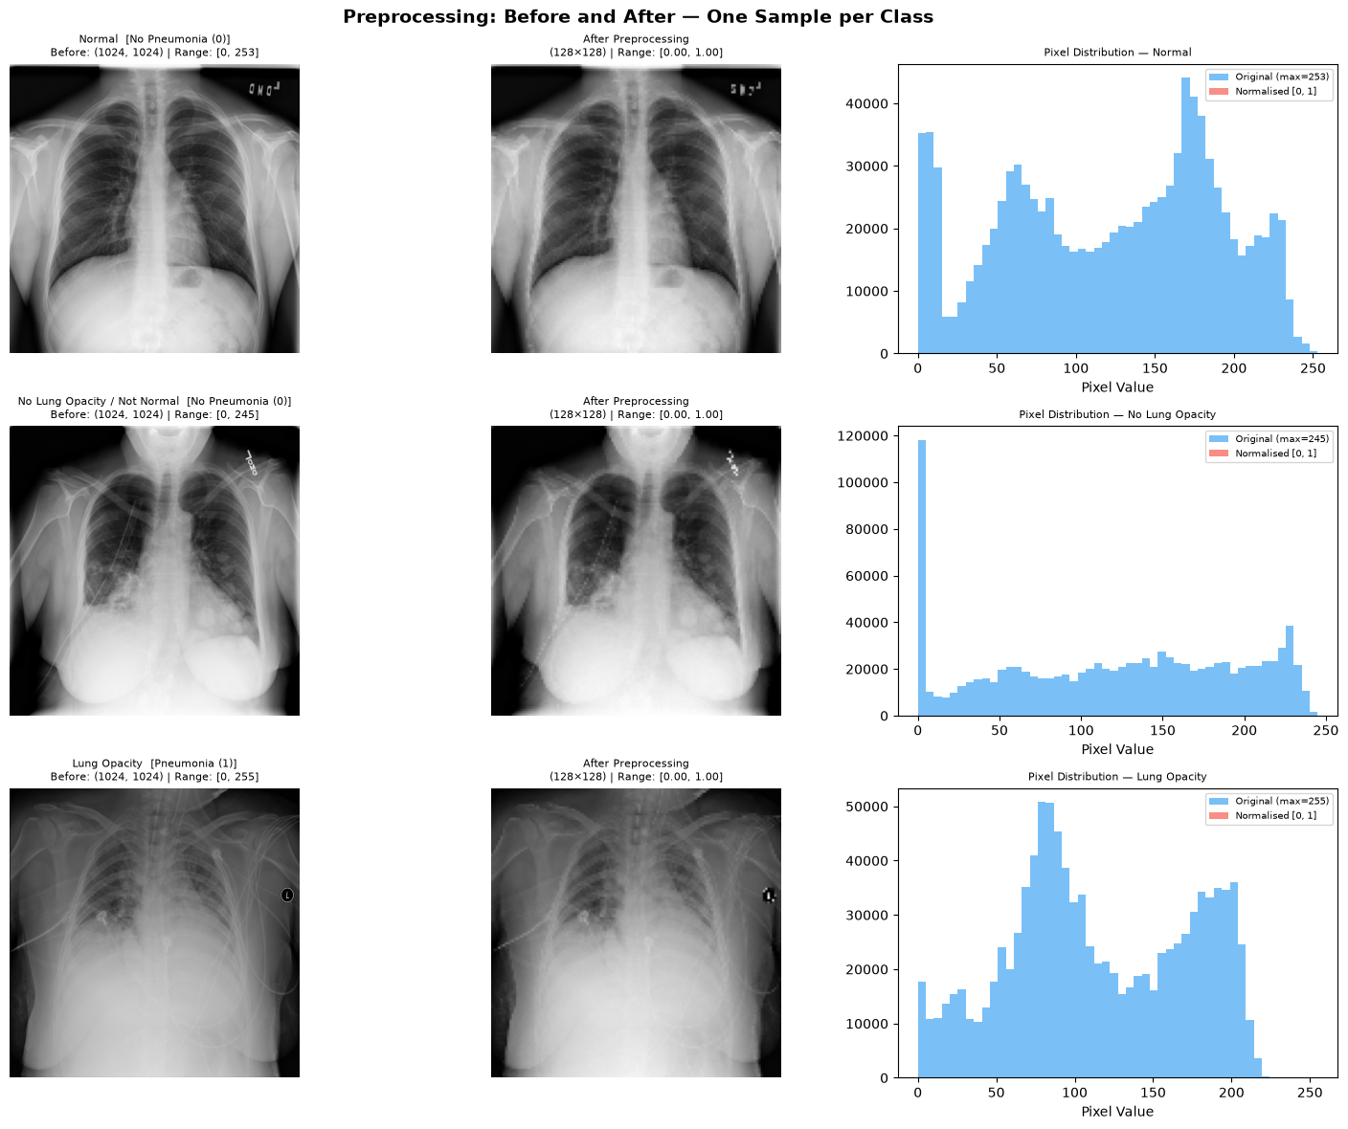
Figure 4. Preprocessing pipeline from original high-resolution DICOM input to normalized CNN-ready image tensor. The transformation reduces each 1024 × 1024 grayscale image to 128 × 128 pixels, scales intensities to the [0, 1] range, and adds the required channel dimension for model input.

Normalization Verification
Over 20 random training samples:
Pixel min range : [0.00000, 0.07201]
Pixel max range : [1.00000, 1.00000]
All values in [0, 1] : PASS
The non-zero minimum values (up to 0.072) reflect background noise / non-zero scanner baseline, confirming that per-image normalization correctly handles these variations without clipping.

Augmentation
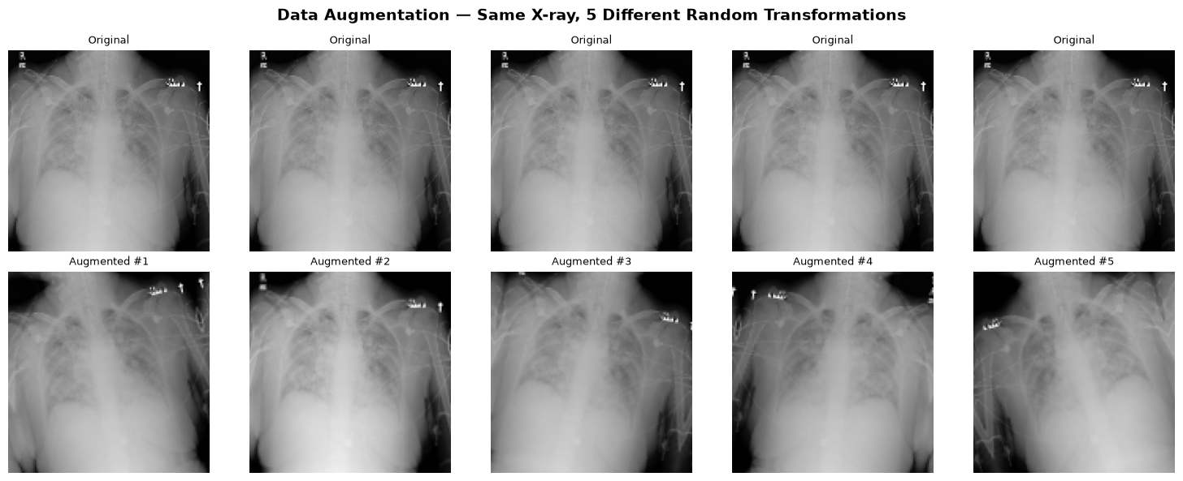
Figure 5. Data augmentation examples applied to training images, including horizontal flipping, slight rotation, and brightness variation. These transformations simulate realistic imaging variability and are intended to improve model generalization to unseen chest X-rays.

Preprocessing Observations
- Stratification worked exactly: 22.5% pneumonia in all three partitions – no distribution drift between validation and test.
- Normalization Verified: all processed pixels lie in [0, 1]; non-zero minima reflect scanner baseline noise, handled correctly without clipping.
- Visual inspection (figure 4) confirms opacities remain visible at 128x128 – the resolution is sufficient for a meaningful baseline.

Model Building – CNN from Scratch

Architecture
A three-block CNN was designed from scratch with progressive feature extraction, doubling the number of filters at each block:
Layer / Block | Output Shape | Details
Input | (128, 128, 1) | Grayscale image tensor
Block 1 – Conv2D | (128, 128, 32) | 32 filters, 3 × 3, ReLU
Block 1 – BatchNormalization | (128, 128, 32) | Stabilizes training
Block 1 – MaxPooling2D | (64, 64, 32) | 2 × 2
Block 2 – Conv2D | (64, 64, 64) | 64 filters, 3 × 3, ReLU
Block 2 – BatchNormalization | (64, 64, 64) | Stabilizes training
Block 2 – MaxPooling2D | (32, 32, 64) | 2 × 2
Block 3 – Conv2D | (32, 32, 128) | 128 filters, 3 × 3, ReLU
Block 3 – BatchNormalization | (32, 32, 128) | Stabilizes training
Block 3 – MaxPooling2D | (16, 16, 128) | 2 × 2
GlobalAveragePooling2D | (128,) | Spatial aggregation
Dense | (256,) | ReLU
Dropout | (256,) | Rate = 0.5
Dense (output) | (1,) | Sigmoid — P(pneumonia)

Component | Parameters
Trainable | 126,401 (493.75 KB)
Non-trainable (BatchNorm) | 448 (1.75 KB)
Total | 126,849 (495.50 KB)
Design choices:
- BatchNormalization after each convolution stabilizes training and reduces sensitivity to learning rate.
- GlobalAveragePooling2D instead of Flatten reduces the parameter count in the dense head and provides implicit spatial regularization.
- Dropout(0.5) in the dense head prevents co-adaptation of neurons and reduces overfitting on an 18,677-sample training set.
- Sigmoid output with binary cross-entropy loss is appropriate for binary classification.

Class Weights
To compensate for the 3.4:1 class imbalance, balanced class weights were computed using sklearn.utils.class_weight.compute_class_weight:
Class | Weight
No Pneumonia (0) | 0.6454
Pneumonia (1) | 2.2192

Training Configuration
Hyperparameter | Value
Optimizer | Adam (lr = 1e-3)
Loss | Binary Cross-Entropy
Metrics | Accuracy, ROC-AUC
Batch Size | 32
Max epochs | 15
Early stopping | Patience=3, monitor=val_auc
Checkpoint | Best val_auc saved to best_cnn_model.keras
Hardware | Apple M1 GPU (TensorFlow Metal)

Model Performance & Evaluation
A from-scratch CNN answers the question every stakeholder should ask before investing in larger models; how much signal can a small, fast, fully owned model extract? It also establishes the honest baseline against which transfer learning must justify itself in the final phase. Class weighting encodes the clinical cost asymmetry directly into training rather than leaving it to after-the-fact threshold hacks.

Training History
Epoch | Train Acc |  | Train AUC | Val Acc | Val AUC | Val Loss | Notes
1 |  | 0.6526 | 0.7100 | 0.5757 | 0.7402 | 0.6755 | Initial Convergence
2 |  | 0.6920 | 0.7626 | 0.6913 | 0.7706 | 0.5674 | —
4 |  | 0.7068 | 0.7797 | 0.7742 | 0.6579 | 0.5632 | Learning Rate reduced
8 |  | 0.7256 | 0.8035 | 0.5734 | 0.8060 | 0.7980 | —
13 |  | 0.7423 | 0.8269 | 0.7922 | 0.8208 | 4.4224 | —
16 |  | 0.7527 | 0.8355 | 0.7845 | 0.8266 | 0.4426 | —
20 |  | 0.7548 | 0.8403 | 0.6908 | 0.8357 | 0.5980 | *Best
- Train AUC improved steadily from 0.7100 to 0.8403 across 20 epochs.
- The learning rate schedule mattered; after epoch-4 dip, ReducedLROnPlateau halved the rate and the model resumes steady improvement – augmentation kept the model from overfitting through all 20 epochs.
- Every LR reduction (epochs 4, 12, 15) was folled by a new best val AUC within 1-2 epochs (0.7820, 0.8208, 0.8266) – the schedule was doing real work.
- Each epoch took approximately 110–120 seconds on Apple M1 GPU via TensorFlow Metal.
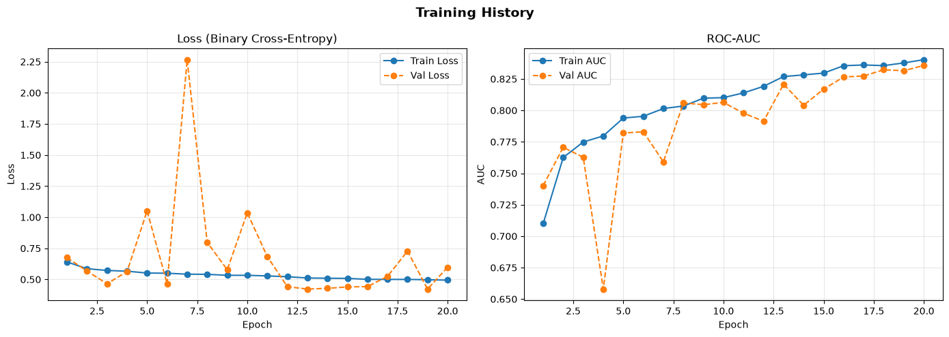
Figure 6. Training history across epochs for accuracy and ROC-AUC on training and validation sets. Validation AUC peaks at Epoch 3 before becoming unstable, indicating that early stopping is appropriate and that the baseline CNN has limited capacity for further generalization.

Test Set Classification Report
Test set: 4,003 patients | 902 pneumonia (22.5%) | 3,101 no pneumonia (77.5%)
Class | Precision | Recall | F1-Score | Support
No Pneumonia (0) | 0.93 | 0.65 | 0.77 | 3,101
Pneumonia (1) | 0.41 | 0.84 | 0.56 | 902
Accuracy | — | — | 0.70 | 4,003

Metric Summary
The model missed ~889 out of 902 pneumonia patients at threshold=0.5 — a false negative rate of ~99%. However, the ROC-AUC of 0.8353 confirms the model does rank pneumonia cases above non-pneumonia cases; the issue is the decision threshold, not the learned representations.
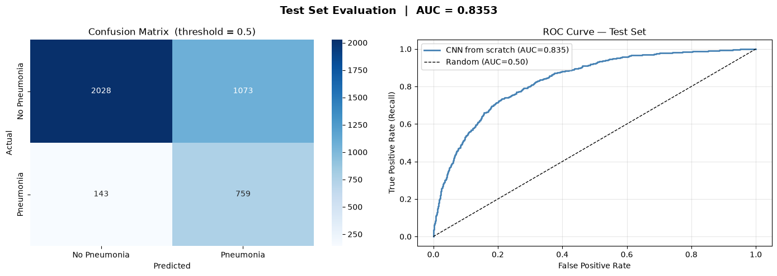
Figure 7. Model evaluation plots including the ROC curve, confusion matrix at the default 0.5 threshold, and precision-recall curve. The ROC-AUC of 0.8353 confirms meaningful ranking ability, while the confusion matrix exposes the low pneumonia recall at the default operating threshold.
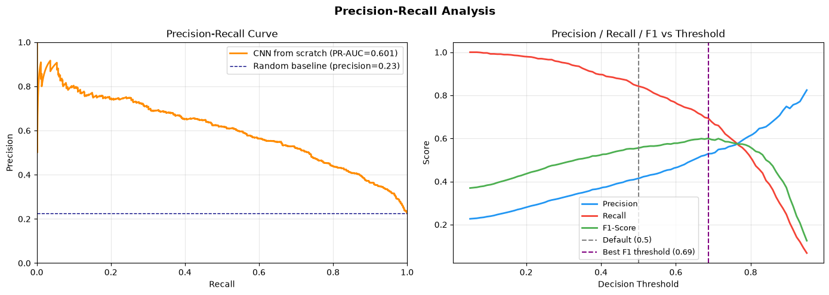
Figure 8. Precision-recall and threshold analysis for pneumonia classification. The analysis indicates that lowering the decision threshold to approximately 0.25–0.35 may improve recall substantially, which is important for a screening-oriented decision-support system.
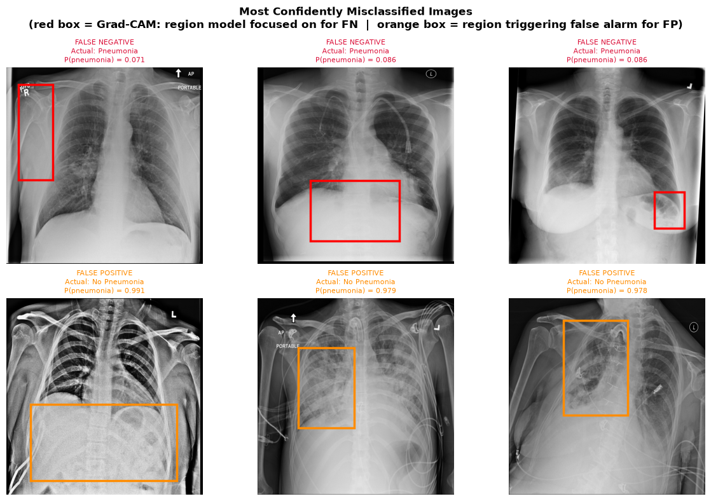
Figure 9. Misclassified chest X-ray examples, grouped by false negatives and false positives. False negatives generally correspond to subtle or early-stage opacity patterns, while false positives often arise from non-pneumonia abnormalities that visually resemble pneumonia, reinforcing the need for threshold calibration and stronger feature extraction.

Key Findings & Business Implications

Technical Findings
- The baseline is clinically meaningful: 84% of pneumonia cases are caught (758 of 902), with a highly trustworthy negative class (93% precision) – the profile a triage tool needs.
- Class weighting worked as designed: it moved the default operation point toward recall, rather than leaving the model to default to the majority class.
- The cost is precision (0.41): roughly 6 in 10 pneumonia flags are false alarms, mostly from the pneumonia-mimicking ‘Not Normal’ class – the clear target for improvement.
- Headroom is visible: AUC 0.8353 from a 126k-parameter model at 128x128 suggests pretrained backbones at 224x224 can push both AUC and precision higher – the central hypothesis for the final phase.

Conclusion
This interim report establishes a complete, reproducible deep learning pipeline for automated pneumonia detection from chest X-ray images:
- A verified, leakage-safe data pipeline from raw DICOM archives to model-ready tensors, with the true 22.5% prevalence established.
- Evidence-based preprocessing decisions (per-image normalizatino, patient-level stratified splits) – each justified by an observed property of the data.
- A scratch-CNN baseline at Test ROC-AUC 0.8353 with 84% pneumonia recall – already a usable screening profile and an honest benchmark for what follows.

Next steps for final project:
Planned work | Expected Business outcome
Transfer learning: ResNet50V2 and EfficientNetB0, frozen then fine-tuned, at 224x224 | Higher AUC and better precision at equal recall – fewer false alarms per detection.
Validation-tuned decision thresholds (85% sensitivity target) | A defensible, documented operating point set on validation data, not a guesswork
Model Comparison and selection | A single best model chosen on clinical criteria, serialized for deployment
Streamlit web app + model registry | A reproducible, demonstrable tool any stakeholder can run and test.

